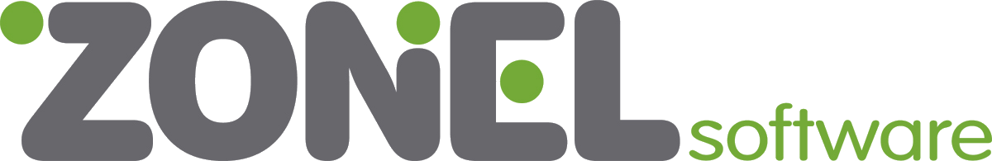

Zonel Software - Solutions that work
Zonel Software delivers an entirely new approach to business software. We inspire businesses by offering choices and flexibility. Zonel Software solutions free our customers from focusing on technology to focusing on what they do —their core, revenue-generating activities.
With an enduring focus on the markets we serve, we inspire businesses. No one else has the same business emphasis, open access, or customer intimacy. Our customers know that Zonel Software solutions open new possibilities, not previously imagined. More than 1,400 customers rely on Zonel Software to help them meet business challenges today, and empower them for even greater success tomorrow. With solutions available in different languages, Zonel Software can reinvent your organization, whether you conduct business locally, regionally, or internationally.
Zonel Software provides end-to-end solutions coupled with the technology expertise you need to increase operational efficiency and drive competitive advantage. With more than 20 years of experience in delivering innovative solutions to our customers, Zonel Software is a visionary and stable partner you can rely on now and in the future.
Our Mission
Be the leading provider of business software that drives growth and profitability for our customers.
Our Values
Innovation

Imagine, Create, Deliver
Teamwork

Better together
Service

Customer first
Excellence

Always make it better
Integrity

Do what we say
Passion

Love what we do

Our Core Values

Our core values define our beliefs, guide our decisions, and drive our actions. They inspire us to be a powerful force in the industry and a great place to work. Our values are seen, heard, and felt every day in our policies, our systems, our operations and our service to customers

